**Checking stationarity of time series data using**

**augmented dickey fuller test.**

**EX:No:4**

**DATE: 04/03/25**

# AIM: To check stationarity of time series data using augmented dickey fuller test.

# CODE AND DESCRIPTION:

# # While the data is non-Stationary

# import pandas as pd

# import matplotlib.pyplot as plt

# from statsmodels.tsa.stattools import adfuller

# import yfinance as yf

# # Load AAPL data using yfinance

# aapl_data = yf.download('AAPL', start='2010-01-01', end='2025-01-01')

# # Use 'Adj Close' as it's adjusted for splits and dividends

# aapl_data = aapl_data['Close']

# def adf_test(series):

# result = adfuller(series)

# print(f"ADF Statistic: {result[0]}")

# print(f"p-value: {result[1]}")

# print(f"Critical Values: {result[4]}")

# if result[1] > 0.05:

# print("The series is non-stationary (fail to reject H0).")

# else:

# print("The series is stationary (reject H0).")

# # Apply the ADF test

# adf_test(aapl_data)

# OUTPUT:



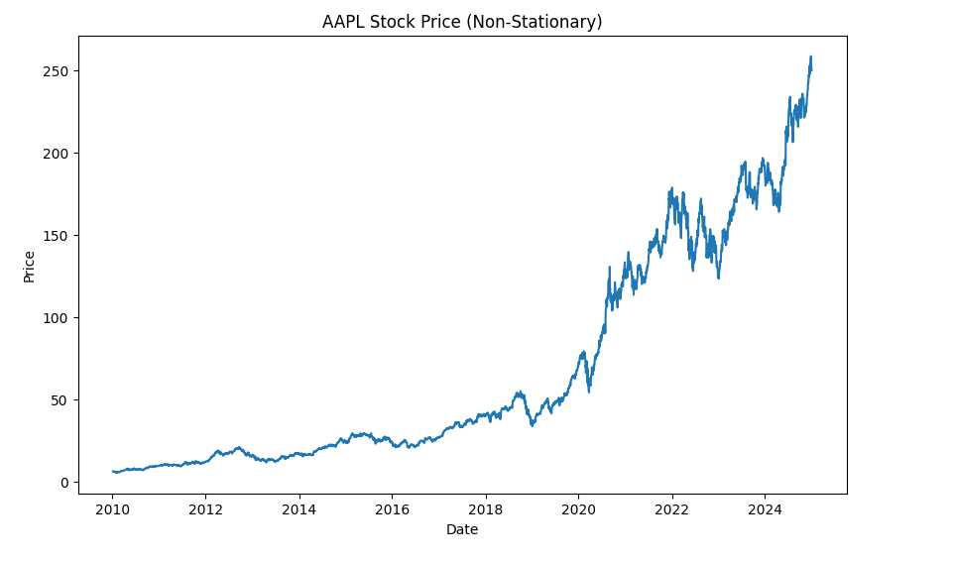

# # After converting the data to Stationary

# First differencing to make the data stationary

aapl_diff = aapl_data.diff().dropna()

# Check the ADF test again after differencing

adf_test(aapl_diff)

# Plot the differenced data to see if it's stationary

plt.figure(figsize=(10, 6))

plt.plot(aapl_diff)

plt.title("Differenced AAPL Stock Price (Stationary)")

plt.xlabel("Date")

plt.ylabel("Differenced Price")

plt.show()

# OUTPUT:



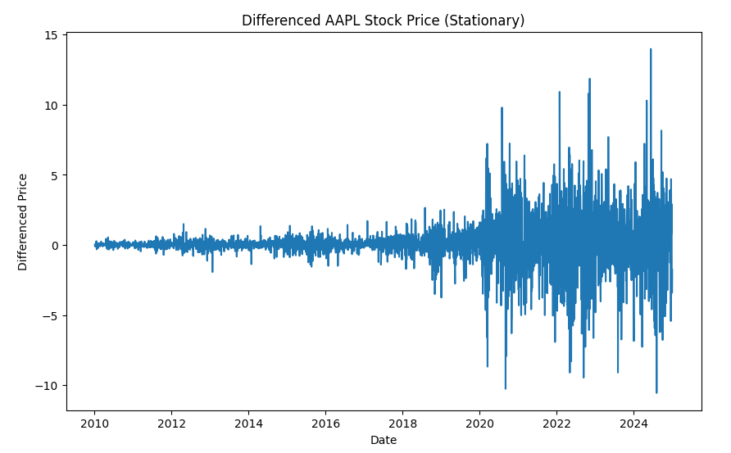

**RESULT:**

Thus, the program has been completed and verified successfully